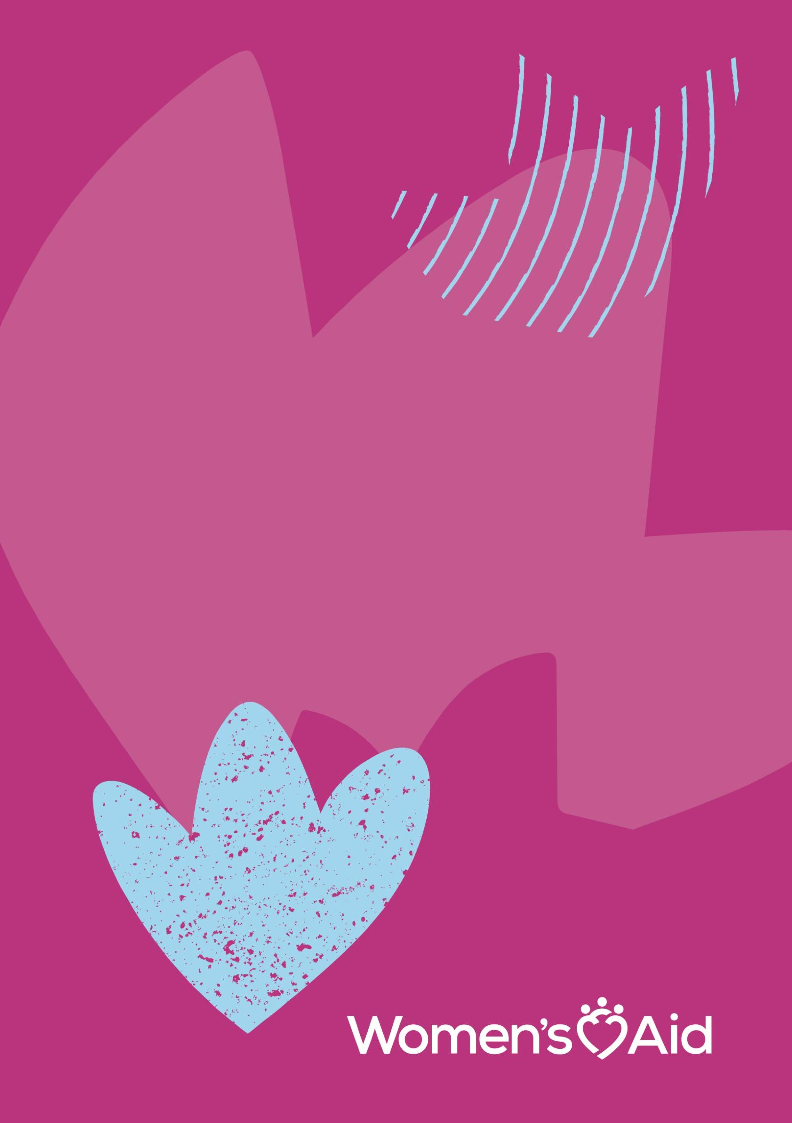

202
6

Women’s Aid
Recruitment Pack

National Freephone Helpline
- Night Support Worker (Maternity Cover) x 1
- Day Support Worker x 1

Table of Contents

Summary 2
About Women’s Aid 4
About the Helpline Team 5
Benefits of Working with Women’s Aid 6
Duties and Responsibilities 8
How to Apply 12
Additional information 13

Summary
Women’s Aid is seeking two experienced, dynamic and motivated team members to join our National Freephone Helpline Department in 2026.

There is one Night Support Worker (Maternity Cover) position and one Day Support Worker position available for the right candidates.

Night Support Worker (Maternity Cover) x 1
- Ref: NFHNSW(MC)10.2026
- Contract: The contract offered is fixed term 6-month contract based on a 33-hour week - on a set 3-week rotating roster, 3 nights x 12 hours shift, excluding 1 hour lunch breaks. Core working hours are ordinarily between 8pm and 8am Monday through to Sunday. Flexibility may be required.
- Location: Primarily in Women’s Aid Head Office in Dublin 2, hybrid working arrangements may be available following successful Induction and training.
- Salary: This role sits on the Women’s Aid Helpline Support Worker Pay Band and the rate offered is (€34,233 - €51,373) per annum, pro rata to 33 hours per week (35hr per week full time).
- Reports: To the Head of National Helpline Services.
- Benefits: Read on to learn about our additional attractive employee benefits.

Day Support Worker x 1
- Ref: NFHDSW10.2026
- Contract: The contract offered is permanent and this role is based on a 28-hour week - set on a 4-week rotating roster, over 7 days per week, each shift is 8 hours, excluding 1 hour lunch breaks. Core working hours are ordinarily between 8am and 8pm, Monday through to Sunday. Flexibility may be required.
- Location²: Working primarily in Women’s Aid Head Office in Dublin 2, hybrid working arrangements of up to 50% work time per week may be available following successful induction and training.
- Salary: This role sits on the Women’s Aid Helpline Support Worker Pay Band (€34,233 - €51,373), rate offered will be commensurate to relevant experience, in line with company remuneration policy.
- Reports: To the Head of National Helpline Services.
- Benefits: Read on to learn about our additional attractive employee benefits.

The Purpose of the Roles
The purpose of each role is to provide support and information to women experiencing abuse in intimate relationships on the Women’s Aid National Freephone Helpline, online Instant Messaging Support Service (IMSS), and Text, and to assist in ensuring maintenance and fulfilment of the responsibilities of the Helpline Service Department as a member of the Helpline Team.

About Women’s Aid
Women’s Aid is a national, feminist organisation working to prevent and address the impact of domestic violence and abuse, including coercive control. We do this by advocating, influencing, training, and campaigning for effective responses to reduce the scale and impacts of domestic abuse on women and children and providing high quality, specialised, integrated, support services.

Women’s Aid Values
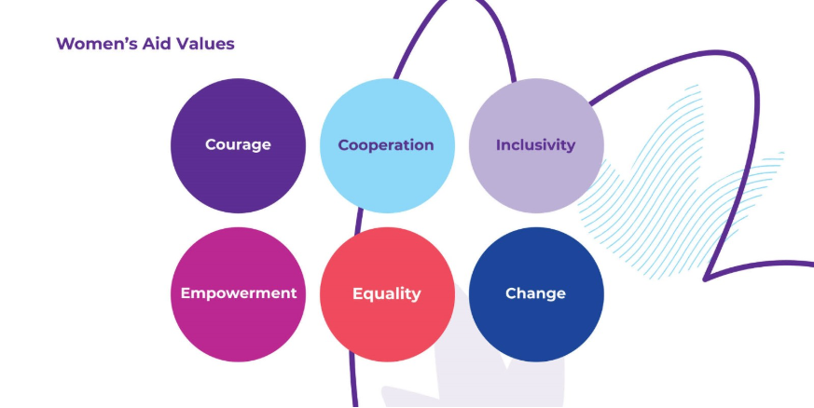

To achieve our purpose and vision of zero tolerance of domestic abuse and all forms of violence against women Women’s Aid:
- Acts with courage to boldly challenge patriarchal systems, structures, and attitudes in all aspect of our work.
- Works in co-operation to share knowledge, skills, and expertise to achieve shared goals and improve responses to domestic violence and abuse.
- Strives to embed inclusivity, diversity, and accessibility across all our work.
- Supports the empowerment of women to exercise agency on their own behalf as a right, whatever their circumstances.
- Believes that achieving equality in status, rights and opportunities for all women is essential to address the causes and consequences of domestic violence and abuse.
- Works to achieve positive change for everyone through a combination of individual, community-based and social action.

Our vision is an equal Ireland with zero tolerance of all forms of violence against women, including domestic abuse. For more information read our current Strategic Plan.

About the Helpline Team
The National freephone helpline (1800 341 900) operates 24/7. It provides essential support services to women experiencing intimate partner abuse/violence. We also offer supports through our Instant Message Support Service, and Text. We also have a Language Line support service to enable us reach out and request an interpreter to support a caller when English is not her first language, for more information about these range of services see link here, https://www.womensaid.ie/get-help/

National Helpline Team Structure
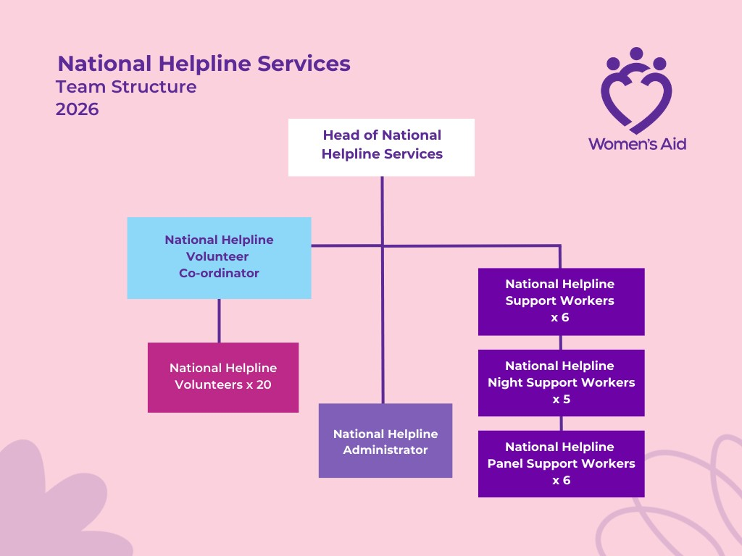

Benefits of Working with Women’s Aid
- Annual Leave: Annual leave entitlement is 25 days per annum pro rata.
- Privilege Days: Good Friday and Christmas Eve.
- Pension: Women’s Aid operates a contributory pension scheme which all employees may join after 6 months in the organisation.
- Maternity Leave: Women's Aid will pay full salary (less Social Welfare benefits) for the period of the 26 weeks paid leave (subject to 1+ year service).
- Parents’ Leave: 9 weeks’ leave topped up to full salary during the first 2 years of a child’s life, or in the case of adoption, within 2 years of the placement of the child with the family for eligible employees.
- Employee Assistance Programme: Women’s Aid provides an extensive employee assistance programme.
- Death in Service Benefit: Available for all employees to the value of 2 years’ salary.
- Trade Union Membership: The staff of Women’s Aid has an option of joining the recognised representative Trade Union Forsa.
- Training Allowance: Annual allowance for staff members to undertake training to enhance skills and expertise (subject to budget availability).
- Travel Supports: Bike-to-work schemes and tax saver commuter tickets.
- We also offer a range of other supports, including paid leave for employees experiencing menopause, problematic periods or subject to domestic abuse.
- Equality and Diversity: Women’s Aid is committed to the promotion of equal opportunities and cultural diversity.
Lived experience
While lived experience as a survivor of domestic abuse is not a requirement for any role in Women’s Aid, we welcome applications from suitably qualified individuals with lived experience.

Duties and Responsibilities
Main Duties:
- To respond efficiently and effectively to the service user’s needs of the National Freephone Helpline, IMSS, text and email contacts.
- To support and empower women experiencing abuse in intimate relationships by providing assistance and information on all their options including legal, financial, housing and making appropriate referrals where necessary.
- To maintain accurate and relevant records through all medium of contacts; input data while on shift, and record trends and communicate same to Head of National Helpline Services, as necessary.
- To provide on-going peer guidance and support to Helpline volunteers and other staff on issues relating to Helpline/IMSS/Email contacts, as required.
- To input and maintain up to date and correct Helpline/IMSS/Text statistics on the database.
- To support with a structured induction to new Helpline volunteers & staff following their formal training, as required.
- To assist in up-skilling of other staff or volunteers on correct and efficient use of the Helpline data collection system, as required.
- To keep up to date with information of relevance to the Helpline Support Worker position (e.g. legal or policy updates/changes, and relevant changes to services which the Helpline make referrals to) and communication of same to the Head of National Helpline Services, as necessary.
- To pro-actively remain informed and up to date on the overall work of Women’s Aid (face to face services; campaigns; policy work).
- To assist in the smooth operations of the National Freephone Helpline department services.
- To work effectively and collaboratively as part of a team.
- To work a pre-arranged rota system of hours.
- To work collaboratively with the Head of National Helpline Services in the maintenance of the National Freephone Helpline 24-hour services.
- To attend one to one supervision sessions with the Head of National Helpline service, team meetings and reflective practice meetings.
Other Duties:
- To liaise with external agencies on behalf of our service users, where necessary.
- To work flexible hours at certain times of the year based on service demands (e.g. Christmas/other holidays/operational pressure points) or at the request of the Head of National Helpline Services.
- To attend team, organisational and other meetings, as required.
- To engage occasionally with colleagues in other Departments (e.g. Strategic Communications, Training, CEO) in identifying and sharing themes and issues which arise on the Helpline in support of the organisations overall Social Change work.
- To contribute positively to the delivery of the Women’s Aid Strategic Plan 2025-2029, and to embody the Values of the organisation.
- To attend internal and external training and events as required.
- Promote the overall aims and values of Women’s Aid.
Competencies and Skills

Essential
- 3rd level qualification, (Level 7, Social Care/Psychology or similar).
- 1 year or more experience of working directly with women subjected to abuse in intimate partner relationships, also via a Helpline.
- Proficient use of IT required i.e. MS Office suite, MS Teams, SharePoint, Database entry skills and excellent technical knowledge and ability using these systems.
- Good knowledge of the Irish law, and legal systems and processes related to domestic abuse (Family law and relevant criminal law) which women may be/may consider engaging in.
- Have a clear understanding of a gendered analysis of Violence Against Women.
- Knowledge, acceptance and implementation of the organisations purpose, mission and values.
- The Helpline Support Worker position requires access to an appropriate confidential workstation at home with access to a high-quality internet service (a company work laptop will be provided) where Hybrid working applies to the position.

Desirable Criteria:
- Completion of the Women’s Aid Helpline training/or similar Helpline specific training.
- Two years’ experience of working on a Helpline.
- Multi-channel use in supporting service users over Helpline, Instant Message Support, Text Message.
- Good knowledge of Irish social welfare, housing and other relevant systems.
- Knowledge of intersectional barriers and options available for women from a range of backgrounds including (but not restricted to) migrant, disabled, Traveller and Roma women.

Competencies
- Constructively solves team related problems in collaboration with the rest of the Head of National Helpline Services and Helpline team, where appropriate.
- Within defined limits uses own discretion to evaluate whether consultation with colleagues and/or Head of National Helpline Services, as necessary.
- Embraces change as an opportunity, not a problem.
- Makes prompt, timely decisions of a non-routine nature after considering all relevant factors and possible outcomes.
- Expresses ideas and objectives of work effectively, both written and verbal communication.
- Excellent verbal communication both internally and externally, where required.
- Explain and support the organisation’s key policy positions externally to individuals, organised groups and other agencies when appropriate.
- Provides important information, quickly, clearly and accurately to Head of National Helpline Services.
- Actively listens to ensure understanding.
- Acknowledges and addresses issues in an honest, open and nonjudgemental manner.
- Shares successes with team members.
- Responds constructively to suggestions, debriefs and supervision.
- Follows through on tasks assigned.
- Maintains the highest standards of professional behaviour and performance and works to ensure due care and discretion is exercised particularly during regular contact with service users and other external parties.
- Maintains appropriate professional boundaries with service users and colleagues.

How to Apply
Submit your interest by completing the application form, clearly referencing the following in the subject line:
- NFHNSW(MC)10.2026 – Night Support Worker (Maternity Cover)
- NFHDSW10.2026 – Day Support Worker
Please send by email only to Michaela McGovern at <michaela.mcgovern@womensaid.ie>
Please note that only application forms are accepted. CVs will not be considered.
Closing date: 12 noon, on 30th October 2026.

Interview schedule:
Successful shortlisted candidates will be invited to first round interviews. It is anticipated that first round interviews will be held on Monday 16th November 2026 online via Zoom.

Additional information
Right to work in Ireland: All applicants must have the right to live and work in paid employment in Ireland for a period of at least two years from the date closing date for applications. Verification of this right will be required by Women’s Aid.

Personal Identification: It is employer policy to seek personal identification of all employees in the form of a recognised form of photo identification (e.g. passport, drivers’ licence or public services card).

Women's Aid strives to be fully inclusive, welcoming and where possible accommodating applicants of all abilities. However, it is important to note that unfortunately, our Head Office building is not currently accessible for wheelchair use.

